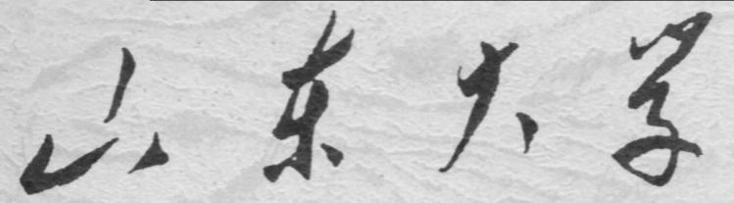

崇新学堂

2025－2026学年第一学期

实 验 报 告

课程名称： 电子信息工程导论
实验名称： Turning Heads

专 业 班 级 崇新学堂
学 生 姓 名 高子轩，钱竹玉，吕思洁，徐亚骐
实 验 时 间 2025年11月12日

Buffering the motor voltage
Objective: Design and build a circuit which can turn the Lego motor in one direction, at a controlled speed.
We added an operational amplifier to buffer the output of the resistor, making it function as a voltage divider

Figure 1: Schematic of the op-amp motor buffer circuit.
Step 5：Simulation in Cmax
We add a Motor Connector to our layout; the motor will be driven by the voltage difference between pins 5 and 6 of this connector and Use CMax to lay out the buffered divider circuit. Then running the simulation will produce several graphs, all of which have time on the x axis, and some other quantity on the y axis. Each signal is sampled at intervals of 0.02 seconds.
Step 6: Measure the voltage across the motor and observe the motor’s behavior.
Check Yourself 3. Compare the behaviors of the circuit with and without the buffer.
No buffer:
We employed a buffer-free circuit as shown below. Due to voltage instability, the circuit malfunctioned, with the motor barely rotating. The image generated by CMax is displayed below.
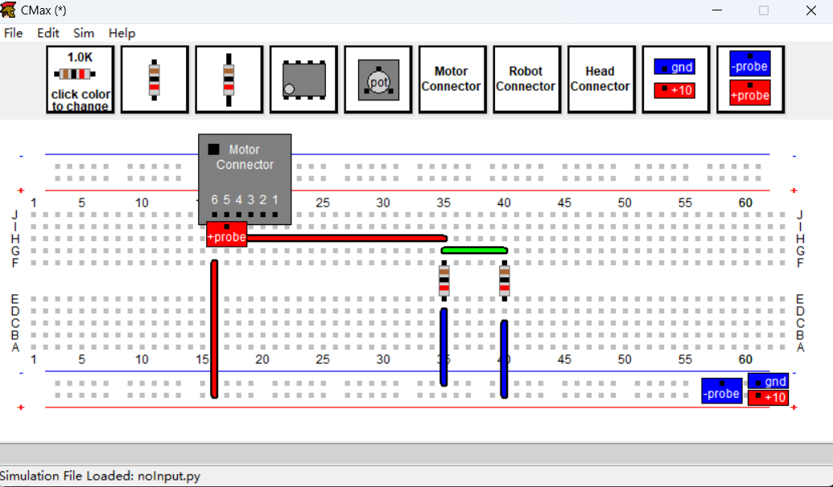 Figure 2 CMax layout of the unbuffered motor circuit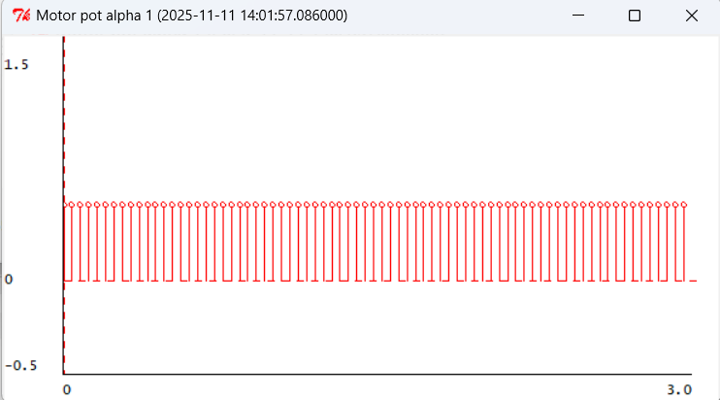
Figure 3 Motor position plot for the unbuffered circuit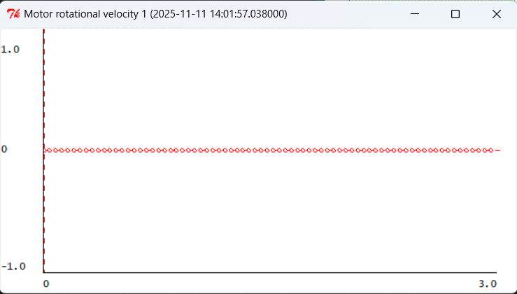
Figure 4 Motor velocity plot (unbuffered), showing no rotation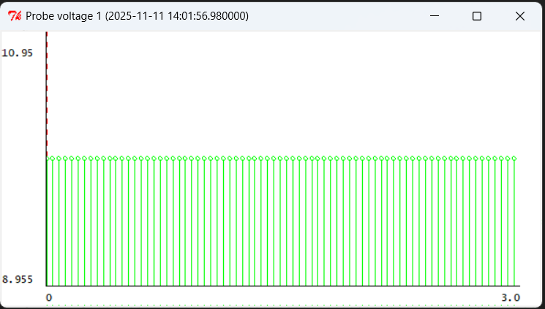
Figure 5 Unstable probe voltage at the motor terminal without buffering

With the buffer:
After adding the buffer circuit, we can clearly observe that the motor rotation has returned to normal and the voltage operation is proceeding as expected. The output image of CMax is shown below.
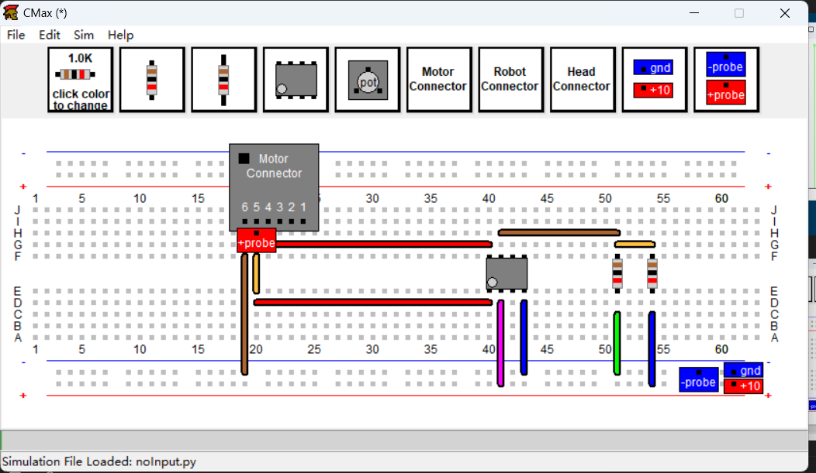 Figure 6 CMax layout of the circuit with an op-amp buffer.
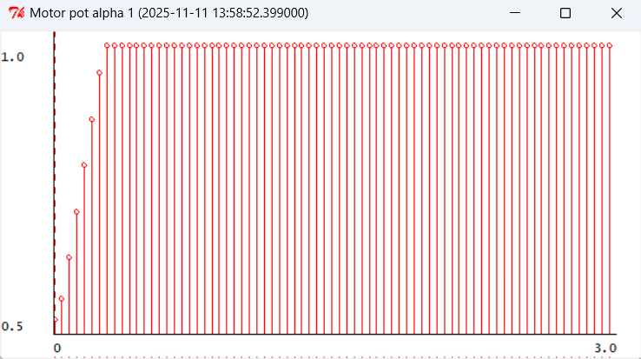 Figure 7 Motor position plot for the buffered circuit.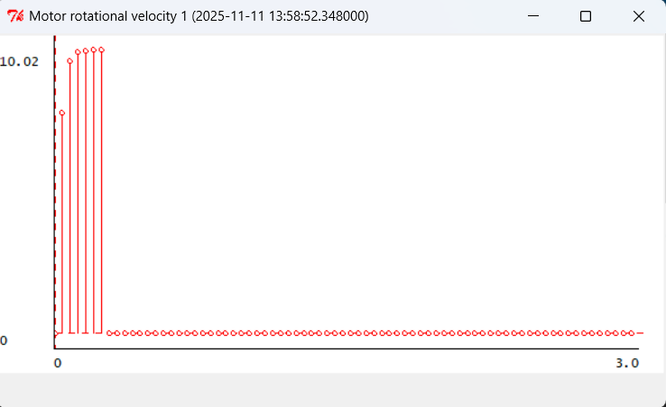
Figure 8 Motor velocity plot for the buffered circuit. 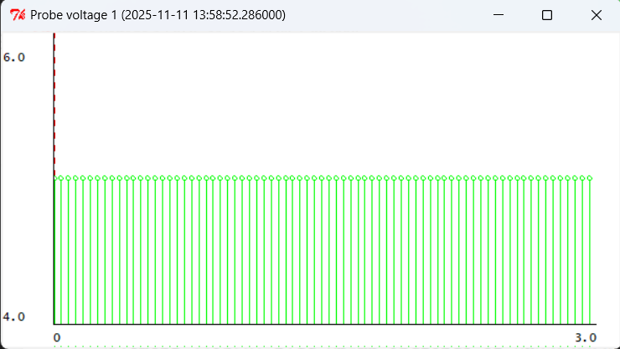
Figure 9 Stable 5V probe voltage at the buffered motor.

Step 7. replace the two resistors in the voltage divider with a potentiometer
So that when α = 0 (the pot is turned as far counter-clockwise as possible), the voltage across the motor is 0, and when α = 1, the voltage across the motor is 10.
Check Yourself 4. Save the CMax circuit and resulting plots
As shown in the figure below, we employed a potentiometer circuit and used CMax simulation to output the voltage and motor speed changes caused by adjusting the potentiometer, as shown below.
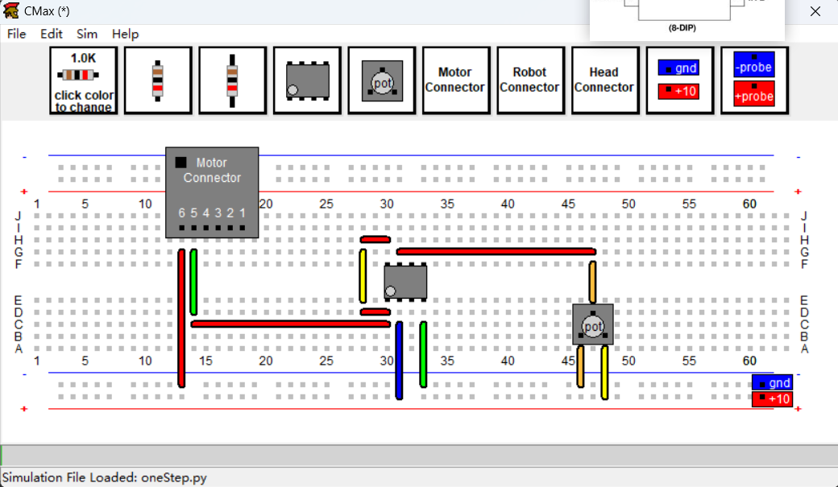 Figure 10 CMax layout using a potentiometer for speed control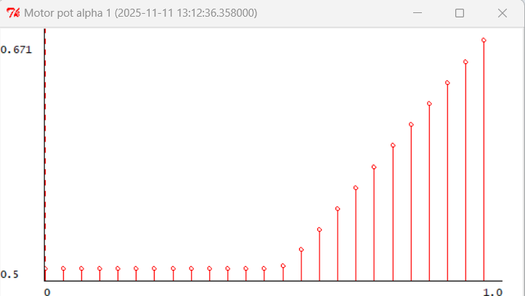 Figure 11 Plot of motor position versus potentiometer setting.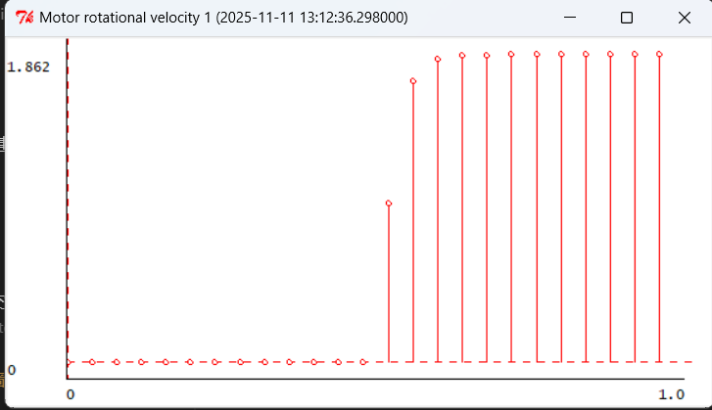
Figure 12 Plot of motor velocity versus potentiometer setting. (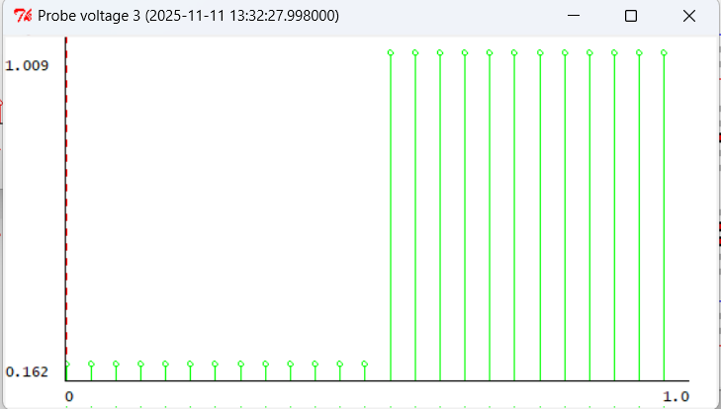
Figure 13 Plot of probe voltage versus potentiometer setting.
Step 8：Replace the resistors in physical circuit with a potentiometer, as in CMax layout.
Step the potentiometer through various settings (1/4 turn, 1/2 turn, 3/4 turn). Observe the behavior of the motor, and compare this behavior to your CMax simulation.
Checkoff1: Explain the differences with and without buffering
The differences: When there is no buffer, the motor rotation speed is 0, and the angle does not change.
When with a buffer, the motor can stably receive voltage, thereby driving the motor to rotate and operate normally. After the angle reaches the maximum, it stops.
Bidirectional Speed Controller
Step 9: Find the suitable $V_{X}$ for the motor
Our answer: Vx =5V
Our goal is to stop the rotation when the voltage difference at both ends is 0, at which point the potentiometer is exactly in the middle, and the voltage output by the operational amplifier is 5V. Therefore, we need $V_{X}$ to also be 5V, so that the motor does not generate a voltage difference and thus does not rotate.
Check Yourself 5. Can you implement $V_{X}$ with just a voltage divider? Explain.
Our answer: No
Our explanation: If only a voltage divider is used, the motor will easily become unstable due to the generation of mechanical energy during rotation. Without an operational amplifier as a buffer, the output voltage will definitely not stabilize at 5V.
Therefore, it is necessary to use the voltage divider with an operational amplifier as a buffer that we have designed as follow: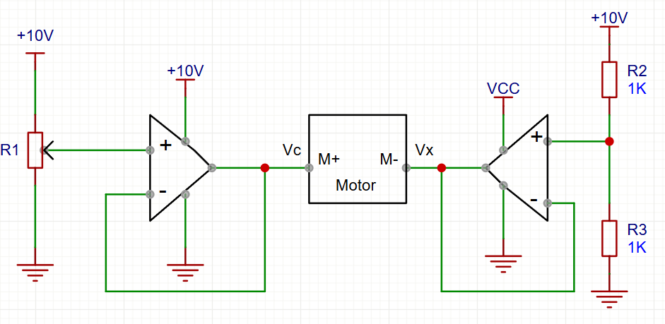
Figure 14 Schematic for the bidirectional motor speed controller.
Step 10: Lay out this circuit using CMax.
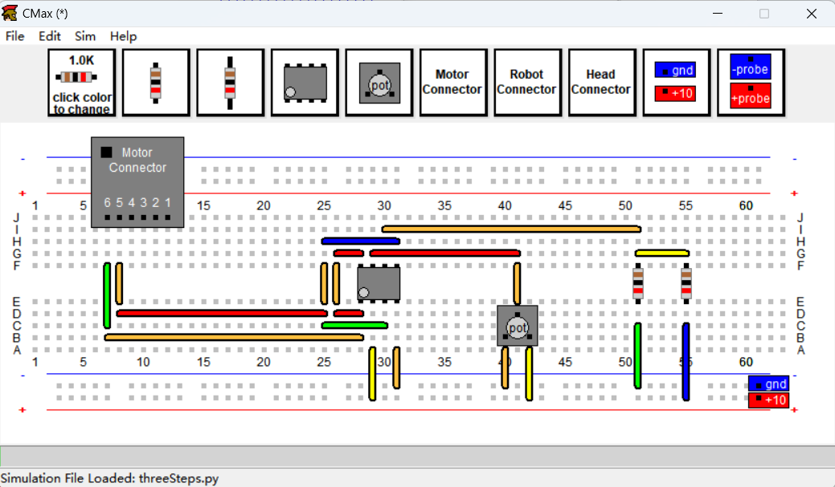
Figure 15 CMax layout of the bidirectional motor controller.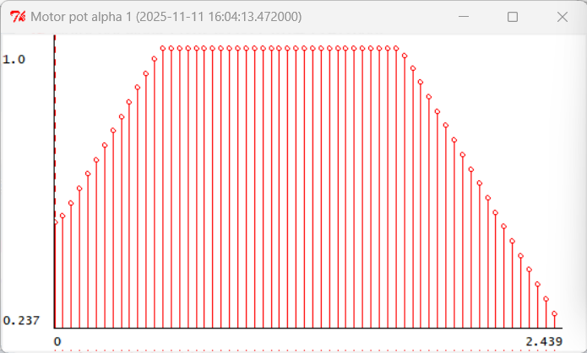
Figure 16 Motor position plot for the bidirectional controller.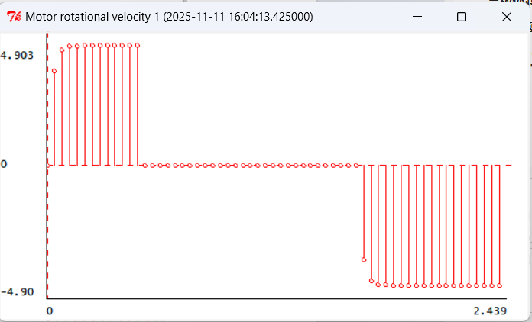
Figure 17 Motor velocity plot showing bidirectional control
Checkoff2: Explain how our circuit accomplishes bidirectional speed control.
Here is our explanation:
The direction of rotation of the voltage depends on the voltage difference. During the process where the voltage difference goes from positive to negative, the direction of rotation of the motor will deflect. We set $V_{X}$ to a constant 5V, and as the potentiometer's resistance changes, the output voltage varies from 10V to 0V, which causes a deflection in the voltage difference and consequently leads to a deflection in the direction of rotation.

Show me the light!
Step 11: Design the circuit for the whole robot.
Design logic:
The Eye location remains the same as before, grounding Pin4 and Pin6, supplying power to Pin5, and then connecting the photoresistor between Pin3 and Pin5. Next, supply power to the motor we just mentioned, which means connecting Pin2 to the power supply.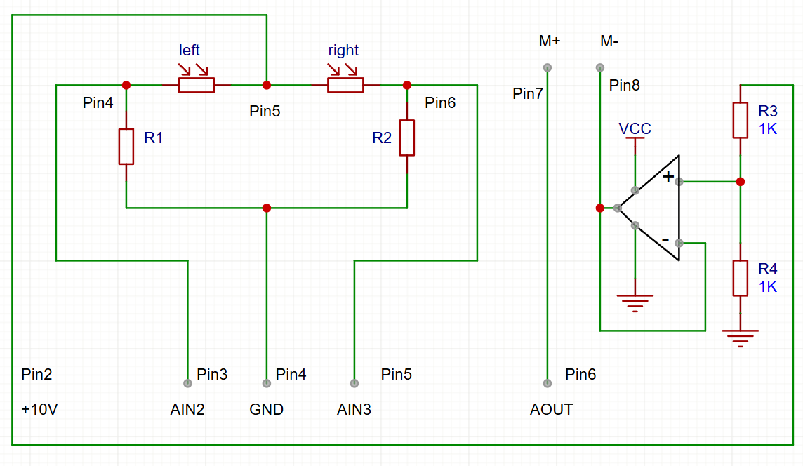
Figure 18 Schematic for the robot "Eye" and $V_{X}$ reference.
Appendix1: Partial Content Description
Due to some issues with the robot, we were unable to obtain the measurement data, so the report omitted the part that required actual measurements.
Appendix2: The Description of AI Usage in the Report
In some parts, to ensure accuracy, we have used a small amount of AI to help us translate and understand the content. Additionally, we have used AI to check the circuit design for us.

